**LAB 3A**

**Wireshark TCP v8.0**

**Name: Hồ Đức Trí**

**Student No: 1912288**

1. What is the IP address and TCP port number used by the client computer (source) that is transferring the file to gaia.cs.umass.edu?

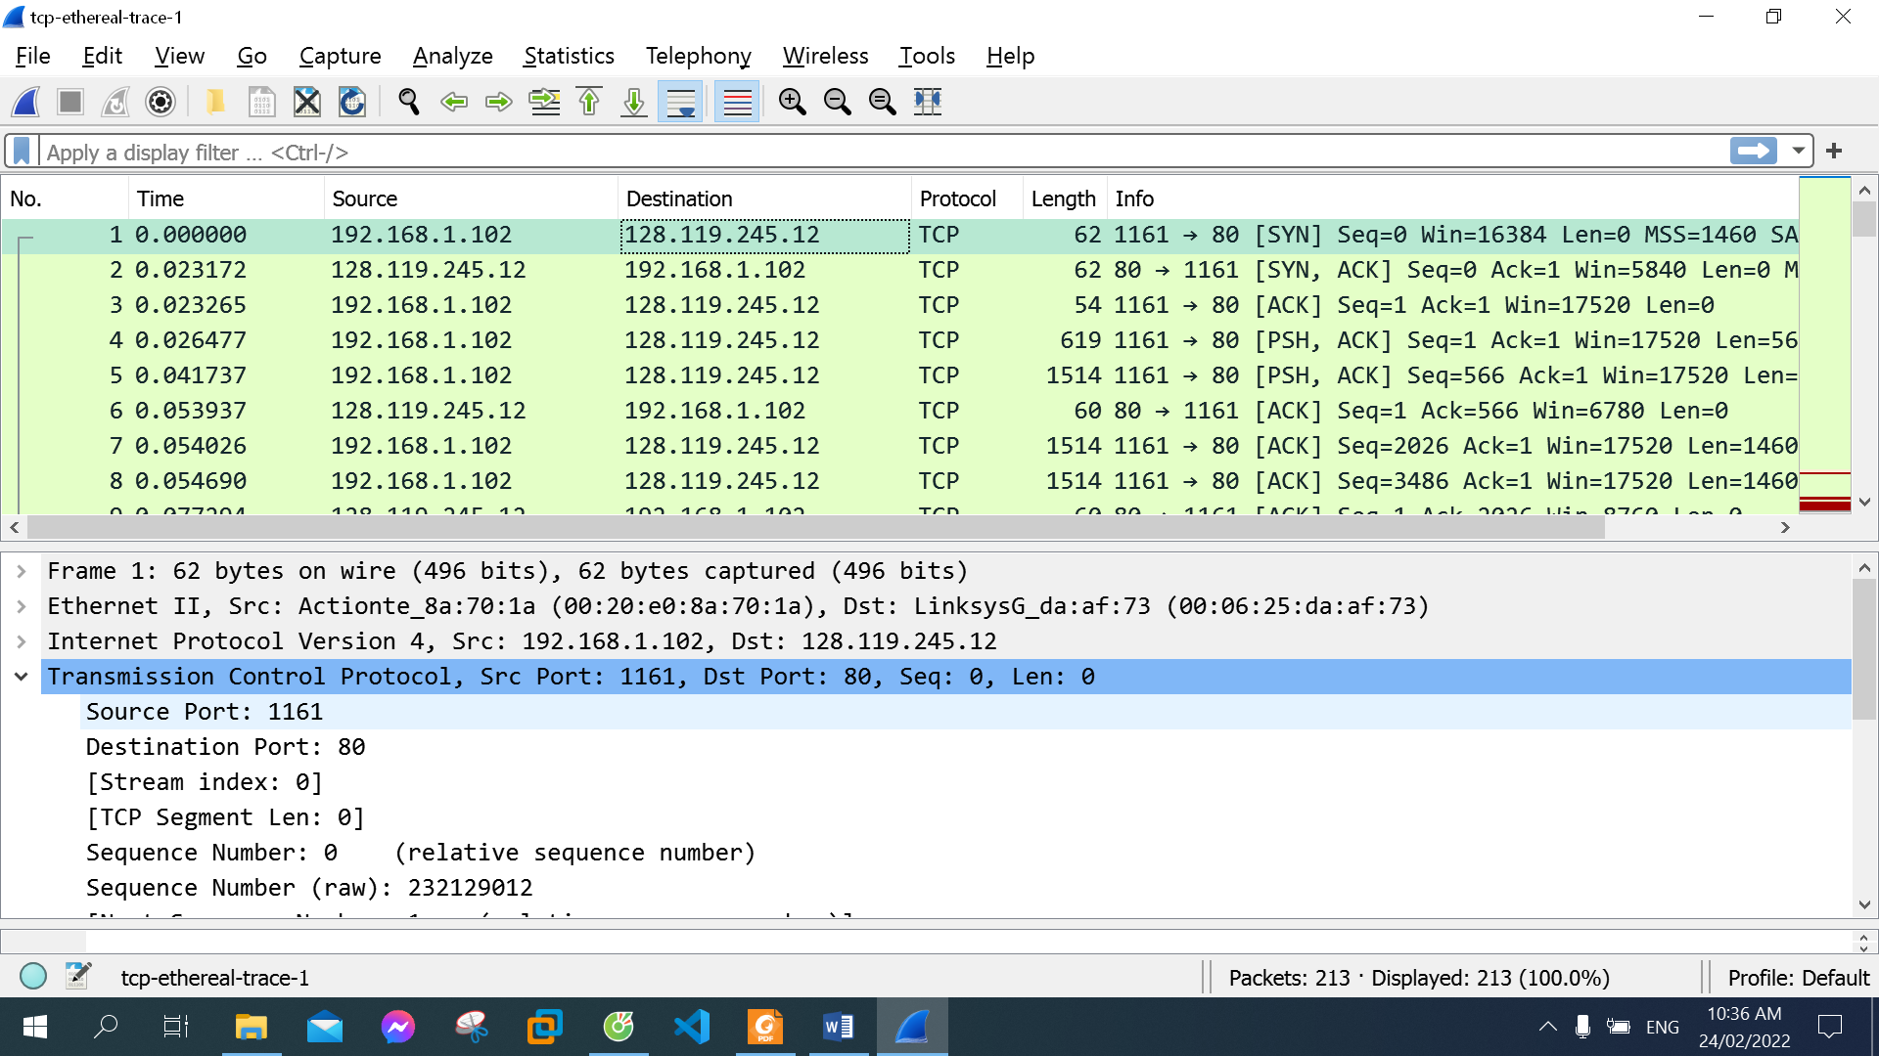

IP address used by the client computer: 192.168.1.102

TCP port number used by the client computer: 1161

1. What is the sequence number of the TCP SYN segment that is used to initiate the TCP connection between the client computer and gaia.cs.umass.edu? What is it in the segment that identifies the segment as a SYN segment?

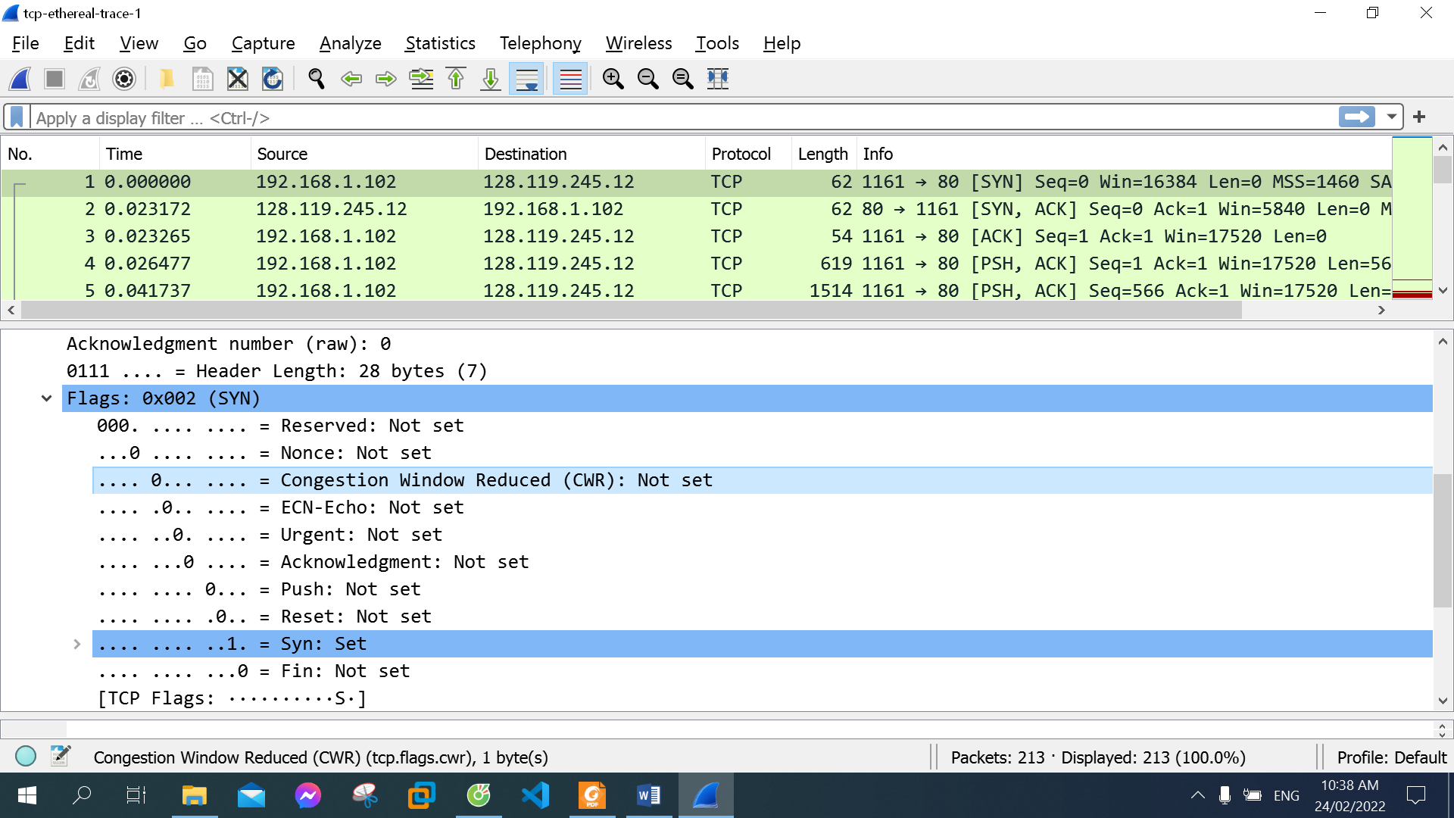

The sequence number of the TCP SYN segment: 0

The line “…. …. ..1. = Syn: Set” in the Flags section

1. What is the sequence number of the SYNACK segment sent by gaia.cs.umass.edu to the client computer in reply to the SYN? What is the value of the Acknowledgement field in the SYNACK segment? How did gaia.cs.umass.edu determine that value? What is it in the segment that identifies the segment as a SYNACK segment?

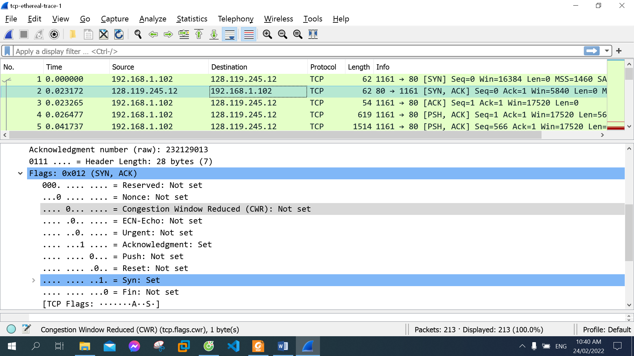

- The sequence number of the TCP SYNACK segment: 0

- The value of the Acknowledgement field: 1

- gaia.cs.umass.edu added 1 to sequence number of the TCP SYN segment and then return to Acknowledgement field

- Syn flag and Acknowledgment flag is set to 1 in Flags section to identify the segment as a SYNACK segment

1. What is the sequence number of the TCP segment containing the HTTP POST command? Note that in order to find the POST command, you’ll need to dig into the packet content field at the bottom of the Wireshark window, looking for a segment with a “POST” within its DATA field.

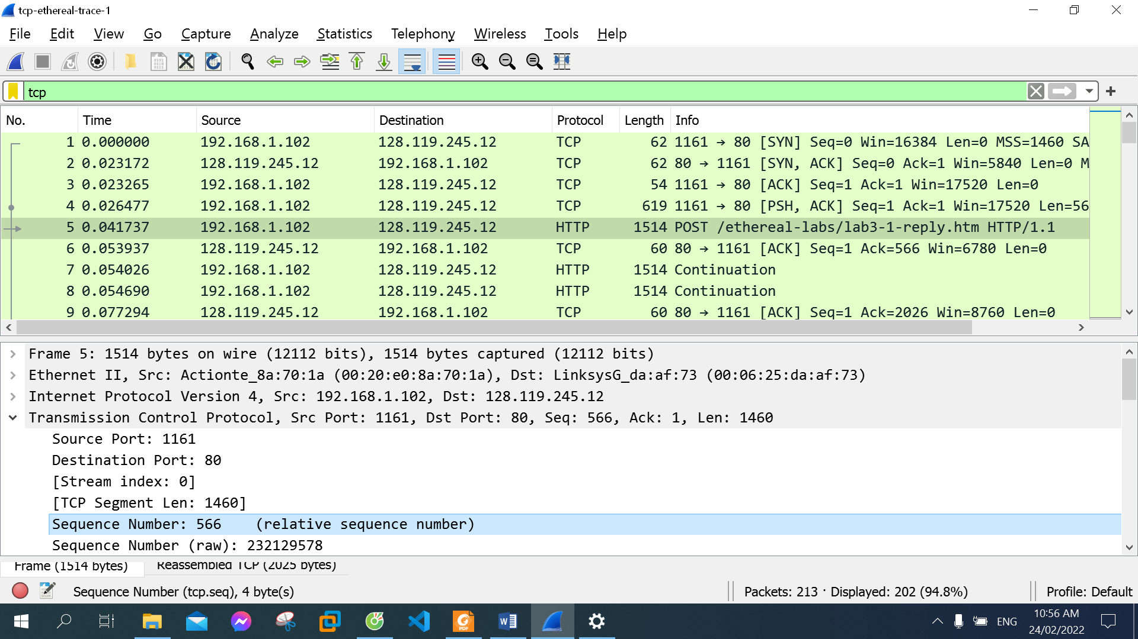

The sequence number of the TCP segment containing the HTTP POST command: 556

1. Consider the TCP segment containing the HTTP POST as the first segment in the TCP connection. What are the sequence numbers of the first six segments in the TCP connection (including the segment containing the HTTP POST)? At what time was each segment sent? When was the ACK for each segment received? Given the difference between when each TCP segment was sent, and when its acknowledgement was received, what is the RTT value for each of the six segments? What is the EstimatedRTT value (see Section 3.5.3, page 242 in text) after the receipt of each ACK?

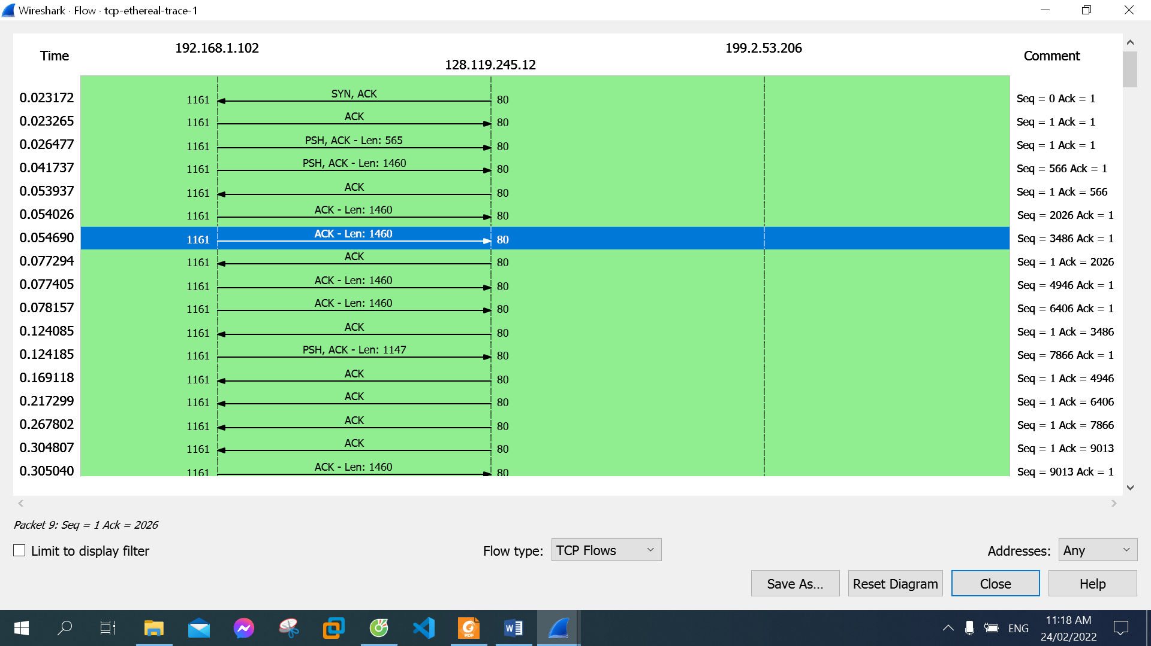

The sequence numbers of the first six segments: 566 -> 2026 -> 3486 -> 4946 -> 6406 -> 7866

Each segment is sent at: 0.041737 -> 0.054026 -> 0.054690 -> 0.077405 -> 0.078157 -> 0.124185

Each segment receive ACK at: 0.053937 -> 0.077294 -> 0.124085 -> 0.169118 -> 0.217299 -> 0.267802

RTT for each segment: 0.0122-> 0.023268-> 0.069395-> 0.091713-> 0.139142-> 0.143617

1. What is the length of each of the first six TCP segments?

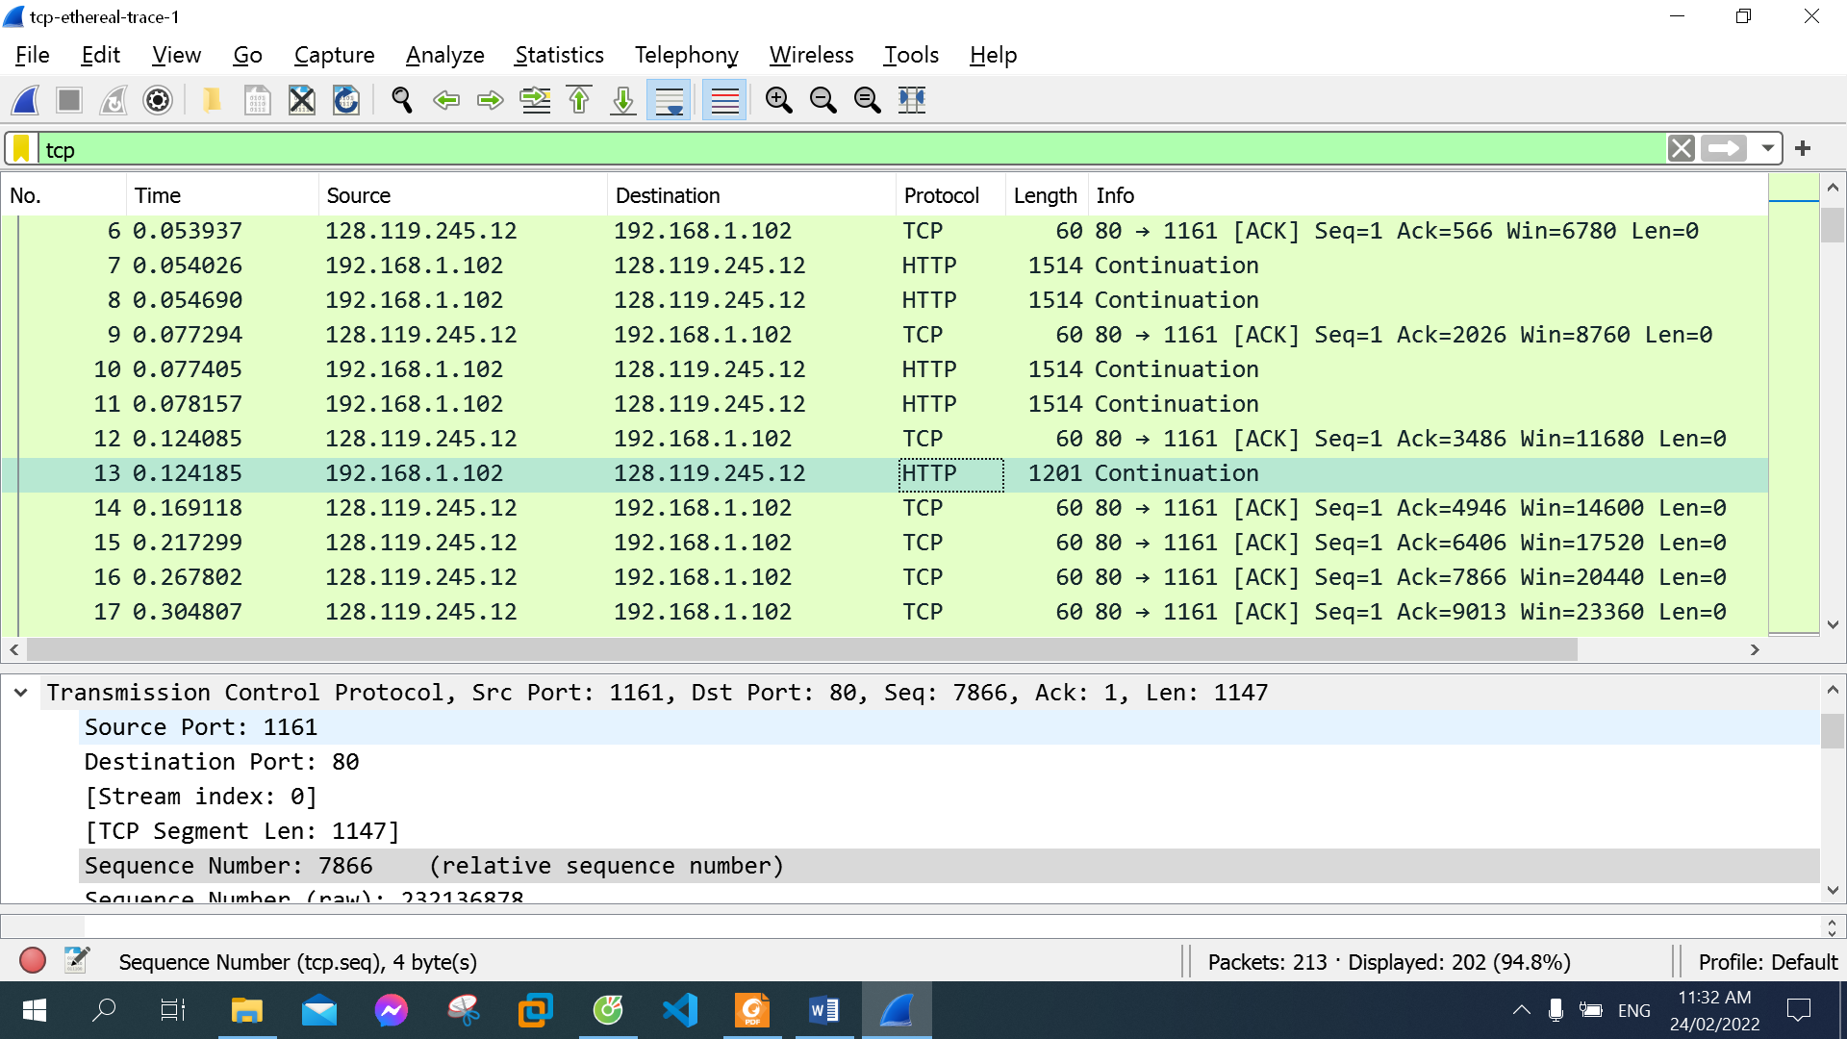

The sixth is 1201, the others are 1514

1. What is the minimum amount of available buffer space advertised at the received for the entire trace? Does the lack of receiver buffer space ever throttle the sender?



- 17520 bytes

- No, it does not

1. Are there any retransmitted segments in the trace file? What did you check for (in the trace) in order to answer this question?

No, no segments were ever retransmitted. This is shown by the fact that an old Acknowledgement number was never resent in order to re-request former packets.

1. How much data does the receiver typically acknowledge in an ACK? Can you identify cases where the receiver is ACKing every other received segment

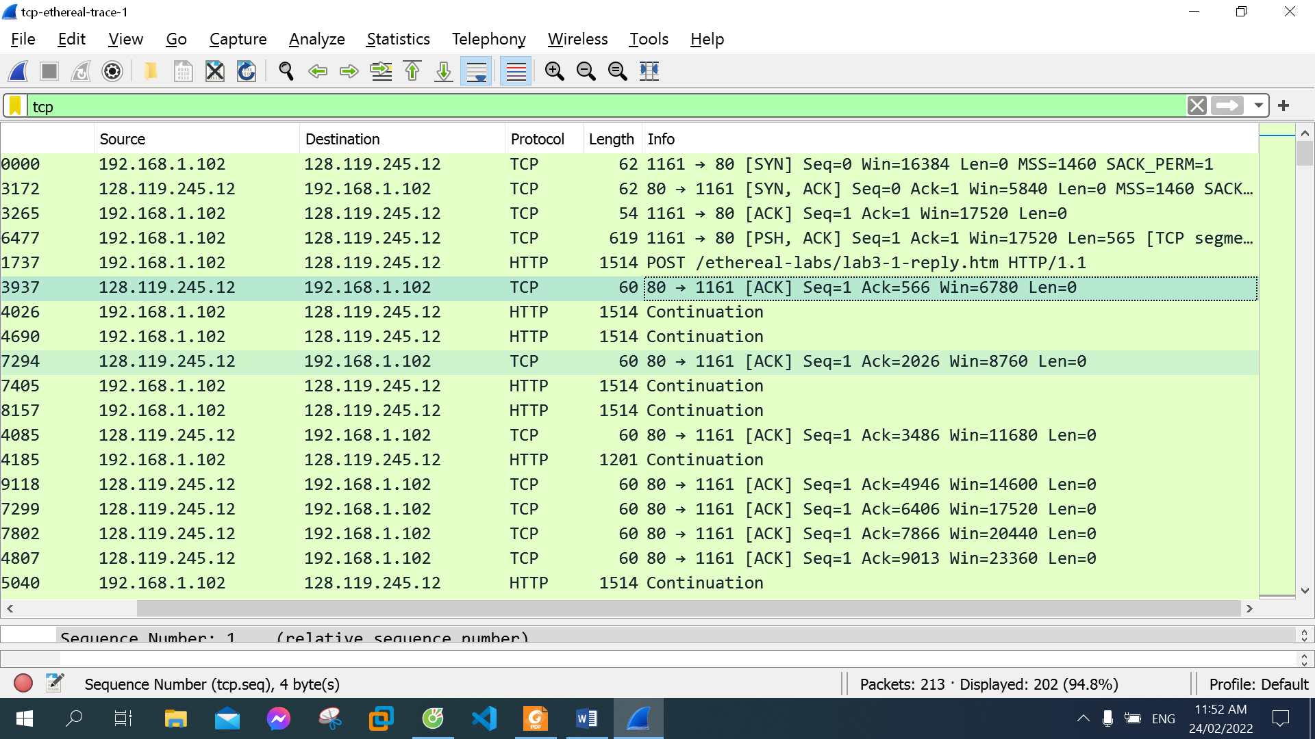

From the screenshot above, we see that the ACK numbers increase in the sequence 566, 2026, 3486, 4946 . . . .

Note that the ACK numbers increase by 1460 each time, indicating that the receiver is acknowledging 1460 bytes.

1. What is the throughput (bytes transferred per unit time) for the TCP connection? Explain how you calculated this value.

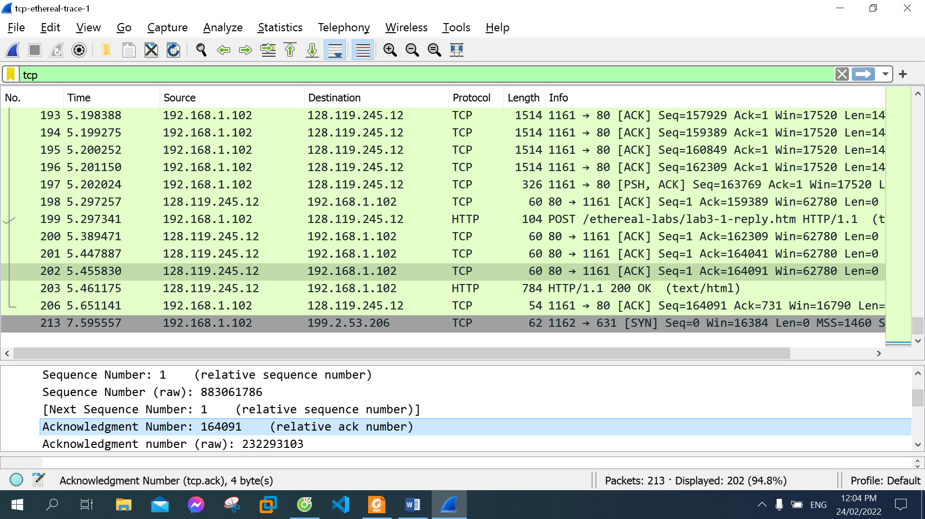

Amount of data transmitted: 164091 bytes

Time incurred: 5.455830 second

Throughput = Amount of data transmitted / Time incurred

 = 164091 / 5.455830 = 30076.2670391 bytes/second